The following questions are based on the podcast entitled:
“What the FinTech? S.2. Episode 23 – An Alternative Approach to Data”
Podcast link:
https://open.spotify.com/episode/1IwI9Mc62tYGsvGbzQ0R3u?si=e37eb4f43d664ed0

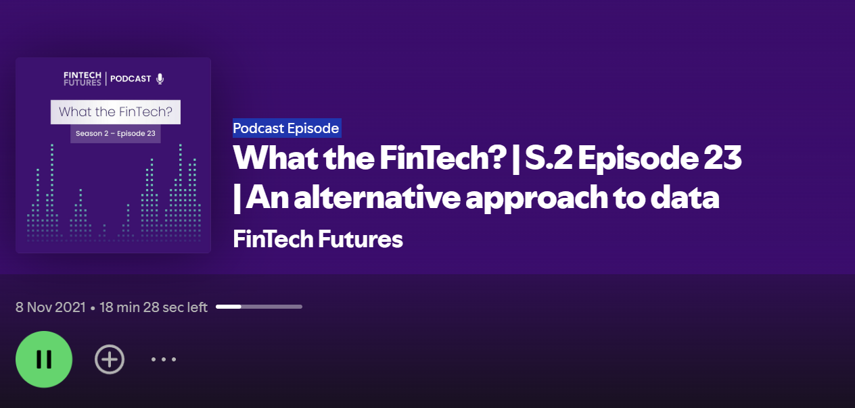

1. The speakers discussed a recent report that showed promising forecasting data from social media, which is expected to continue to grow until 2028. Why is social media data becoming increasingly important in the alternative data market?

Answer Guide:
- Social media data is abundant and accessible. There are billions of people using social media platforms, and they are constantly generating new data. This data is also relatively easy to access, through public APIs or through data providers.
- Social media data is informative. Social media posts, images, and videos can provide insights into a wide range of topics, including consumer sentiment, brand performance, and market trends.
- Social media data is predictive. By analysing social media data, businesses can identify patterns and trends that can be used to predict future events, such as product demand or customer churn.
- Four years ago, the alternative data market was still in its early stages of development, but businesses were beginning to recognize the value of social media data. As a result, there was a growing demand for alternative data providers that could collect and analyse social media data.

Examples of how social media data is being used by businesses today:
- Consumer product companies use social media data to track consumer sentiment and identify trends in product demand.
- Financial institutions use social media data to assess creditworthiness and make lending decisions.
- Retailers use social media data to target their marketing campaigns and improve their customer service.
- Media companies use social media data to identify trending topics and produce content that is relevant to their audience.
The alternative data market is expected to continue to grow in the coming years, and social media data is likely to play an increasingly important role in this market.

Why social media data is becoming increasingly important in the alternative data market:
- The growing popularity of social media. Social media platforms have become an essential part of many people's lives, and the amount of time people spend on social media is increasing. This means that there is more social media available than ever before.
- The development of new social media analytics tools. New technologies are being developed all the time to help businesses collect, analyze, and interpret social media data. This makes it easier for businesses to extract valuable insights from social media data.
- The growing recognition of the value of social media data. Businesses are increasingly recognizing the value of social media data for decision making. This is driving demand for social media data and for alternative data providers that can collect and analyze this data.

Additional:
How oil tracker, in the context of fintech, refers to financial products or services that
track the performance of the oil market. These can include oil exchange-traded funds
(ETFs), oil futures, or other instruments that allow investors to gain exposure to the
oil market without physically owning or trading oil. Oil trackers can have several
impacts on the fintech industry:

- Investment Opportunities: Oil trackers provide investors with an opportunity to gain exposure to the oil market without directly trading oil commodities. This widens the range of investment options in fintech, allowing individuals and institutions to diversify their portfolios.
- Risk Management: Fintech platforms often provide tools for risk management and hedging. Oil trackers can be used for this purpose, allowing businesses in various industries to mitigate risks associated with fluctuations in oil prices, as they can be used as a part of a broader risk management strategy.

- Integration with Digital Platforms: Fintech companies can integrate oil trackers into their digital platforms, providing users with easy access to real-time data, analytics, and trading capabilities related to the oil market. This enhances the user experience and keeps investors informed.

- Diversification of Portfolios: Fintech platforms often encourage diversification by offering a range of asset classes for investment. Oil trackers add to the options available, allowing investors to diversify their portfolios with exposure to the energy sector.

- Education and Analysis: Fintech platforms can offer educational resources and analysis tools related to oil trackers, helping users make informed investment decisions. These resources can include market insights, historical data, and predictive analytics.

- Mobile Trading and Accessibility: Fintech enables users to trade and invest in oil trackers through mobile apps and online platforms, making it easier for a broader audience to participate in the oil market.
- Automation and Algorithmic Trading: Fintech can facilitate algorithmic trading in oil trackers, enabling automated strategies that react to market conditions and news in real-time.

- It's important to note that investing in oil and oil-related instruments can carry significant risks, as oil prices are subject to volatility and various geopolitical and economic factors. Individuals and businesses should thoroughly research and understand these investments before using oil trackers as part of their fintech strategies.

2. The speakers mentioned that ship trackers are used to track oil spills and monitor oil levels on the sea surface. What alternative data sources do you think will be used for this purpose? Describe the process by which the alternative data is created.

Answer Guide:
- Tank level sensors: Tank level sensors can be used to set alarms if the oil level in a tank gets too high or too low. This can help to prevent overfilling or emptying of the tank, which can lead to leaks.

- Flow meters: Flow meters can be used to calculate the amount of oil that is being discharged from a ship. This information can be used to ensure that the ship is not discharging more oil than is allowed.

- Social media data: Social media posts, images, and videos can be used to identify oil spills and to track their movement. For example, the Twitter account @oilspilltracker uses social media data to track oil spills around the world.

- AIS data: AIS (Automatic Identification System) data provides information on the location, speed, and course of ships. This data can be used to track the movement of oil tankers and to identify any potential oil spills. For example, the website Marine Traffic uses AIS data to track the movement of ships around the world.

- Radar data: Radar data can be used to detect oil spills and to estimate the size of the spill. For example, the European Maritime Safety Agency (EMSA) uses radar data to monitor for oil spills in European waters.

Some examples of how alternative data is being used to track oil coming off ships and monitor oil levels today:
- The environmental monitoring company SkyTruth uses satellite imagery to detect and track oil spills.
- The maritime intelligence company Windward uses AIS data to track the movement of oil tankers and to identify any potential oil spills.
- The financial data provider Refinitiv uses financial data to track the oil market and to provide insights on the likelihood of oil spills occurring.

3. The speakers mentioned that alternative data has caused fundamental shift affected strategies for investors. Discuss the challenges in data gathering and analysis.

Answer Guide:
- Data privacy
- Data is noisy
- Data ambiguity
- Not appropriate username
- Analytics depends on data; however, it is difficult to analyse unreliable data
- Most crucial data to handle – unstructured data generated by signals or real-time data.
- Real-time data helps in real-time financial monitoring.
- Unstructured data generated by signals or real-time data is the most crucial data to handle because it is often the most difficult to collect, process, and analyse.
- Signals can be generated by a wide range of devices and sensors, such as smart thermostats, industrial machines, and medical devices. This data can be very rich and informative, but it can also be very complex and challenging to process.
- Real-time data is data that is generated and processed as it is being created. This type of data is often critical for businesses and organizations to make timely decisions. For example, financial institutions use real-time data to monitor stock prices and detect fraud.
- The challenge of handling unstructured data generated by signals or real-time data is that it is often voluminous, fast-moving, and complex. This can make it difficult to collect, store, process, and analyse the data in a timely and efficient manner.

The challenges of handling unstructured data generated by signals or real-time
data:

- Volume: The volume of unstructured data can be overwhelming. For example, a single sensor can generate thousands of data points per second.
- Velocity: Unstructured data can be generated in real time, which can make it difficult to keep up with the flow of data.
- Variety: Unstructured data can come in a wide variety of formats, such as text, images, audio, and video. This can make it difficult to develop processing and analysis tools that can handle all the different data formats.
- Complexity: Unstructured data can be very complex and difficult to interpret. For example, a sensor may generate a data point that indicates a change in temperature. However, it can be difficult to determine what caused the change in temperature without additional context.
- Handling unstructured data generated by signals or real-time data is important for businesses and organizations to stay competitive in the digital age. By collecting, processing, and analysing this data, businesses can gain valuable insights into their operations, customers, and markets.

Here are some examples of how businesses are using unstructured data
generated by signals or real-time data:

- Manufacturing companies are using sensor data to monitor their production lines and identify potential problems before they cause disruptions.
- Retailers are using customer data to track customer behaviour and preferences. This data is then used to improve marketing campaigns and product recommendations.
- Financial institutions are using real-time data to monitor market trends and detect fraud.
- Healthcare providers are using patient data to monitor patient health and identify potential health problems early.

